Writing a Ratio as a Fraction or Linear Function Questions
OCR Thursday 05 November 2020- Morning (Non-Calculator) Foundation Tier
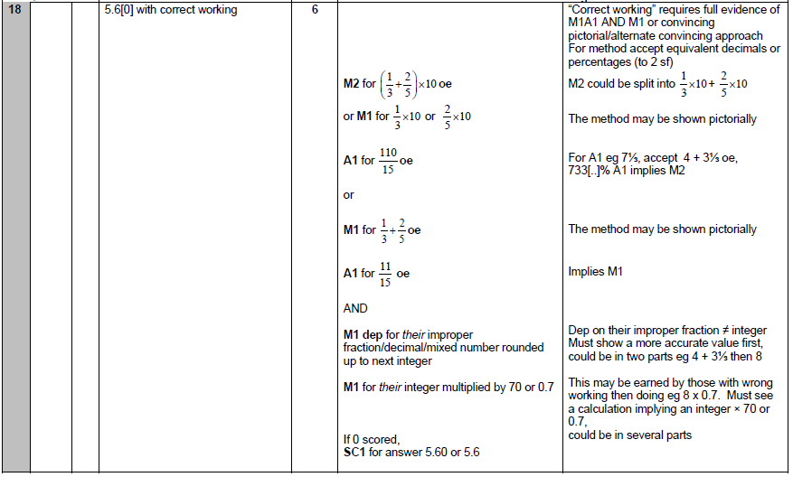

OCR Tuesday 11 June 2019 – Morning (Calculator) Foundation Tier

OCR Tuesday 6 November 2018 – Morning (Calculator) Foundation Tier
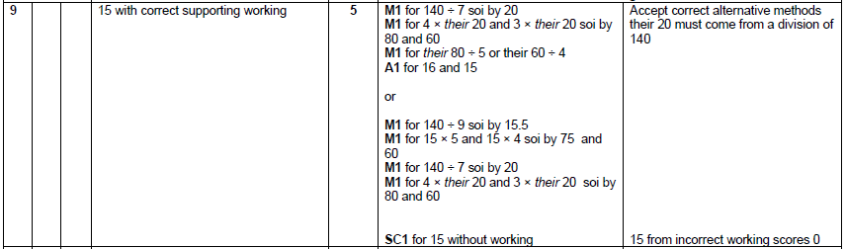

OCR Sample Question Paper 2 – Morning/Afternoon (Non - Calculator) Foundation Tier

